***Define Your Style with the Perfect Dressing Mirror***

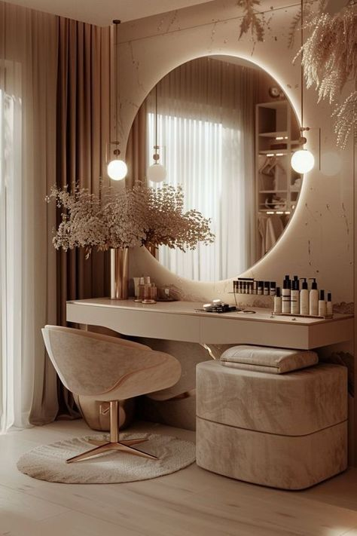

A dressing mirror is more than just a functional piece — it is your daily companion in self-expression, confidence, and preparation. Our premium **Dressing Mirrors** are designed to offer crystal-clear reflections, stylish aesthetics, and unmatched practicality to your dressing area or bedroom corner. Whether you’re getting ready for work, an event, or a casual day out, the right mirror elevates your routine from ordinary to effortless.

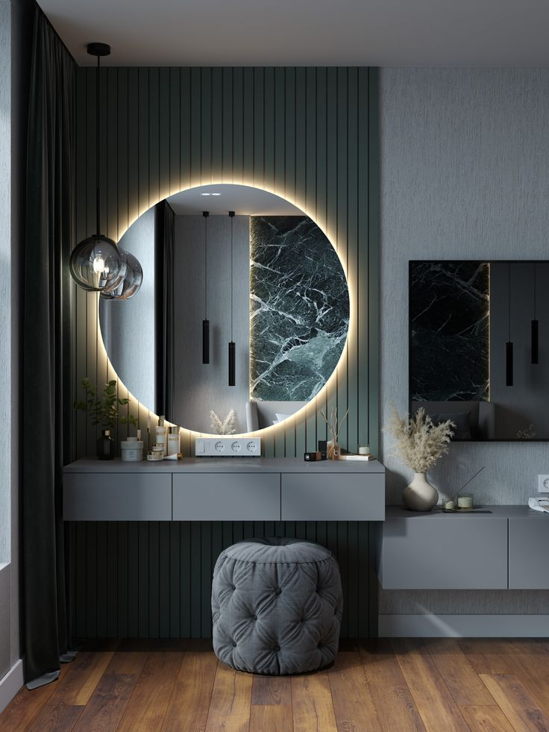Choose from full-length standing mirrors, elegantly framed wall mirrors, or modern foldable vanity styles — all crafted to suit diverse interiors and personal tastes. Each mirror provides a distortion-free reflection, allowing you to see every detail with clarity. Our dressing mirrors are not just made to be looked into, but admired as a design feature that enhances the overall ambiance of your space.

Constructed using high-quality materials, these mirrors are sturdy, durable, and easy to maintain. Whether you prefer minimalist metal frames, classic wooden finishes, or sleek borderless designs, our collection ensures you find a mirror that reflects your personality as beautifully as your appearance.

Style starts here — with a mirror that understands your rhythm and refines your daily routine.